**Topics: Normal distribution, Functions of Random Variables**

1. **The time required for servicing transmissions is normally distributed with *μ* = 45 minutes and *σ* = 8 minutes. The service manager plans to have work begin on the transmission of a customer’s car 10 minutes after the car is dropped off and the customer is told that the car will be ready within 1 hour from drop-off. What is the probability that the service manager cannot meet his commitment?**
2. **0.3875**
3. **0.2676**
4. **0.5**
5. **0.6987**

**Ans:**

The time required for servicing transmission is normally distributed with mean 45 and standard deviation 8

The exact work is begun on the transmission of car 10 minutes after car is dropped.

Therefor the average time increases 45 to 55

Then,

**Z= (X-u)/S.D**

**= (60-55)/8**

**= 5/8**

**= 0.625**

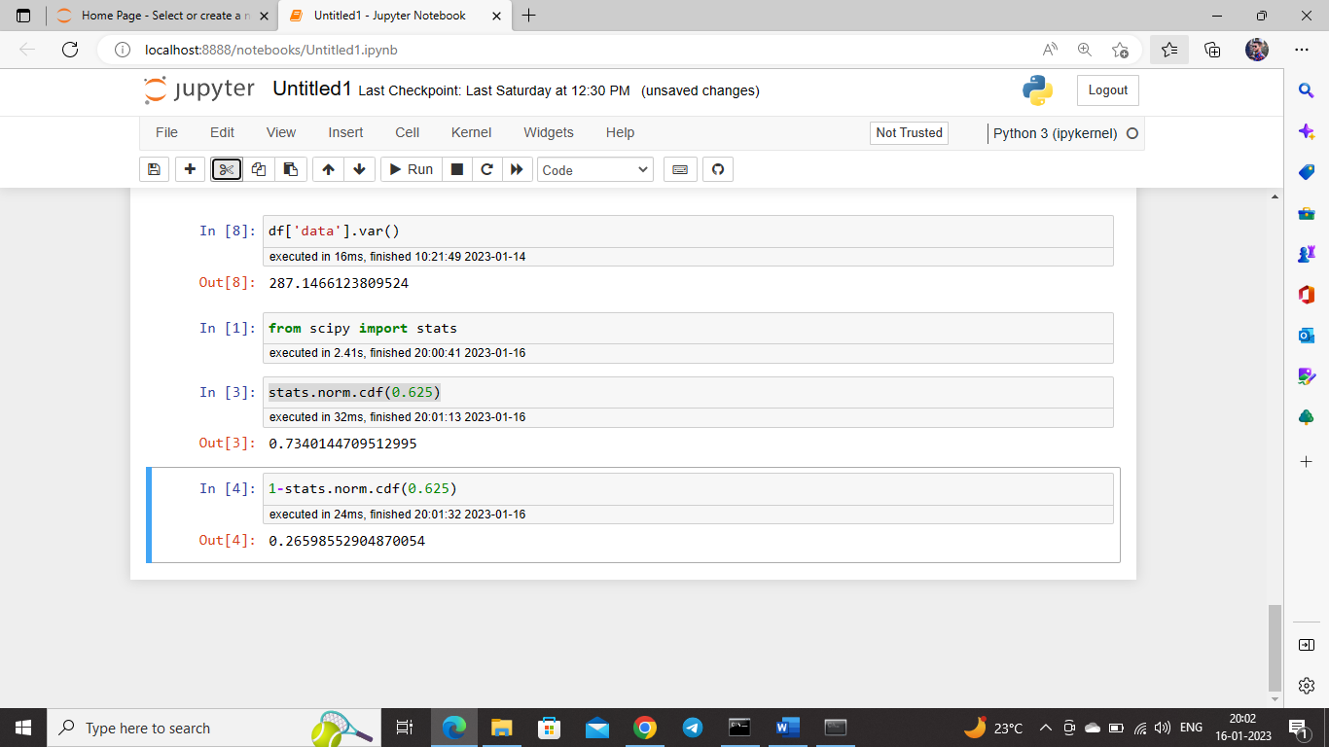By python we calculate the probability,



1. **The current age (in years) of 400 clerical employees at an insurance claims processing center is normally distributed with mean** *μ* **= 38 and Standard deviation** *σ* **=6. For each statement below, please specify True/False. If false, briefly explain why.**
2. **More employees at the processing center are older than 44 than between 38 and 44.**
3. **A training program for employees under the age of 30 at the center would be expected to attract about 36 employees.**

**Ans:**

For A)

**More employees at the processing center are older than 44 than between 38 and 44.**

The employees at processing center at age 44 is,

**Z = (44-38)/6**

**= 6/6**

**= 1**

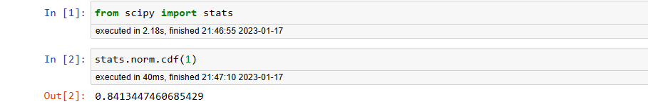

i.e. the probability of people below 44 age is 84.13%

Therefore, the peoples above 44 age is,

100-84.24 = 15.87%

Then,

**15.87% of 400 is 63**

Therefore, we can say that there is 63 peoples who has their age greater than 44 out of 400.

The employees at processing center at age 38 is,

**Z = (38-38)/6**

**= 0**

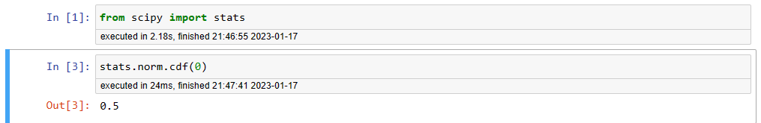

i.e. the probability of people below 38 age is 50%

Therefore, the peoples who has their age in between 44 and 38 is,

**84.13-50= 34.13**

Then,

**34.13% of 400 is 137**

Therefore, we can say that there are 137 peoples who has their age greater than 44 out of 400.

**More employees at the processing center are older than 44 than between 38 and 44 is FALSE**

B). **A training program for employees under the age of 30 at the center would be expected to attract about 36 employees.**

**Z = (30 – 38)/ 6**

**= -8/6**

**= -1.33**

Hence,

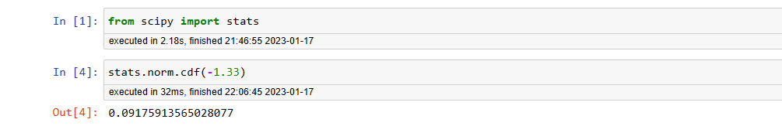

A training program for employees under the age of 30 is 9.17%

Therefore**, 9.17% of 400 is 36**

**A training program for employees under the age of 30 at the center would be expected to attract about 36 employees is TRUE**

1. **If *X1* ~ *N*(μ, σ2) and *X*2 ~ *N*(μ, σ2) are *iid* normal random variables, then what is the difference between 2 *X*1 and *X*1 + *X*2? Discuss both their distributions and parameters.**

**Ans:**

According to the **Central Limit Theorem**, sum of two independents normally distributed random variables is normal.

Therefore,

**X1 +X2 = *N*(μ+ μ, σ2+ σ2)**

**= N(2μ, 2σ2)**

**And,**

**2X1 = N(2μ, 4σ2)**

The mean of 2X1 and X1 + X2  is same but the var() of  2X1 is 2 times more than the variance of X1 + X2

1. **Let X ~ N(100, 202). Find two values, *a* and *b*, symmetric about the mean, such that the probability of the random variable taking a value between them is 0.99.**
2. **90.5, 105.9**
3. **80.2, 119.8**
4. **22, 78**
5. **48.5, 151.5**
6. **90.1, 109.9**

**Ans:**

Given that, mean = 100 and standard deviation is 20.

We have to find values of a and b such a way that, standard normal area enclosed is 0.99.

We have to exclude the area of 0.005 in right and left tail.

Hence, we have to find 0.5th percentile and 99.5th Percentile.

By using python,

Z-value at 0.5th Percentile is,

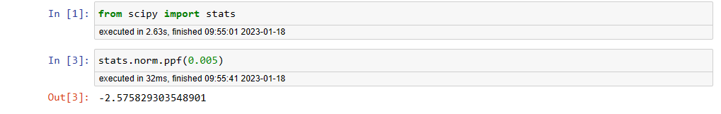

Z-value at 99.5th Percentile is,

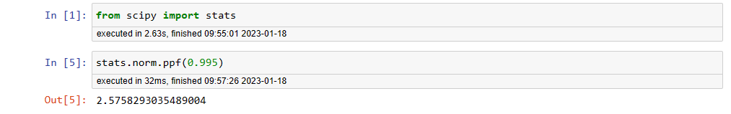

Z = (X-100)/20

X= (20 * Z ) + 100

Therefore, we put Z-value at 0.5th Percentile and Z-value at 99.5th Percentile at this equation,

X = -(20 * 2.5758) +100

= **48.5**

X = (20 * 2.5758) + 100

= **151.5**

1. **Consider a company that has two different divisions. The annual profits from the two divisions are independent and have distributions Profit1 ~ N(5, 32) and Profit2 ~ N(7, 42) respectively. Both the profits are in $ Million. Answer the following questions about the total profit of the company in Rupees. Assume that $1 = Rs. 45**
2. **Specify a Rupee range (centered on the mean) such that it contains 95% probability for the annual profit of the company.**
3. **Specify the 5th percentile of profit (in Rupees) for the company**
4. **Which of the two divisions has a larger probability of making a loss in a given year?**

**Ans:**

1. **Specify a Rupee range (centered on the mean) such that it contains 95% probability for the annual profit of the company.**

We have given that,

Our profit is, N(5, 32) and N(7, 42)

Therefore Company profit is, N(5+7, 32 + 42) = N(12, 52)

95% of the probability lies between 1.96 standard deviation from mean.

Therefore, the range is,

= (12 – 1.96 * 5, 12 + 1.96 * 5)

= ( $2.2*M,* $ 21.8*M*)

= (2.2 * 45, 21.8 * 45)

= (99*M* Rs, 981*M* Rs)

1. **Specify the 5th percentile of profit (in Rupees) for the company**

To compute 5 th percentile, we use the formula X = μ + Zσ; wherein

from z table, 5 th percentile = -1.645 X= 540+(-1.645) * (225)

Therefore, 5th percentile of profit (in Million) is 202.05 million

1. **Which of the two divisions has a larger probability of making a loss in a given year?**

**The division 2.**